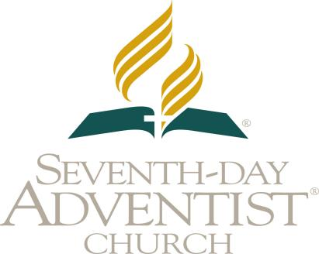



**CONFERENCE OR MISSION**

**HEALTH ACTIVITIES REPORT**

**SOUTHERN AFRICA INDIAN OCEAN DIVISION**

Name of Conference or Mission: Phone:

Address: Email Address:

Union Located

Period of Reporting: Union Located:

Total Districts: Districts Reporting:

|  |  |
| --- | --- |
| **SUMMARY: HEALTH ACTIVITIES FROM ALL THE DISTRICTS IN THE MISSION or CONF** | **TOTAL** |
| 1. Comprehensive and Blended Ministries Health Promotions |  |
| 2. CELEBRATIONS Promotions |  |
| 3. NEWSTART Lectures |  |
| 4. Cancer Prevention |  |
| 5. International Commission for Prevention of Alcohol & Other Dependencies |  |
| Stop Smoking |  |
| Fight Against Alcoholism and its use |  |
| Drug Awareness |  |
| Campaigns and Help Against Addictions (Pornography, Video Games, etc) |  |
| 6. HEALTH EXPO |  |
| 7. Health Programs with Evangelistic Efforts |  |
| 8. Number of Baptisms due to Health and Evangelism programs |  |
|  |  |
| 9. Radio &TV Health Programs Broadcasting |  |
| 10. Health Programs using Social Media Platform (Facebook, You Tube, Twitter, etc) |  |
| 11. Health Programs in conjunction with Government and other NGOs |  |
| 12. Maternal Health, Child Health and Malnutrition Campaigns |  |
| 13. Vegetarian cooking demonstrations and nutrition classes |  |
| 14. Vaccination Promotion |  |
| 15. Non-Communicable Diseases Prevention (high BP, Diabetes, Obesity, high Cholest) |  |
| 16. Mental Health |  |
| 17. AIDS & HIV- Orphan and People Living with HIV care |  |
| AIDS & HIV- Voluntary Counseling and Testing |  |
| AIDS & HIV – Income Generating Activities |  |
| AIDS & HIV Awareness- Fight Against Stigma and Discrimination |  |
| 18. Other Health Programs not listed above like Youth Alive and others |  |

Reported by: Designation

Date of Reporting: